**Koneru Lakshmaiah Education Foundation**

**(Deemed to be University)**

**FRESHMAN ENGINEERING DEPARTMENT**

**A Project Based Lab Report**

**On**

**Train ticket**

**SUBMITTED BY:**

I.D NUMBER NAME

180030628 T. SOWMMYA

180030646 P. SIVA

180030651 T. NITHISH CHANDRA VYAS

180030657 G. VINOD

**UNDER THE GUIDANCE OF**

**PATHURI SIVA KUMAR**

**ASSOCIATE PROFESSOR**



**KL UNIVERSITY**

Green fields, Vaddeswaram – 522 502

Guntur Dt., AP, India.

**DEPARTMENT OF BASIC ENGINEERING SCIENCES-1**



**CERTIFICATE**

This is to certify that the project based laboratory report entitled “<TITLE>” submitted by Mr./Ms**. T. SOWMMYA, P. SIVA, T. NITHISH CHANDRA VYAS,G.VINOD** bearing Regd.No.180030628,180030646,180030651,180030657 to the **Department of Basic Engineering Sciences-1, KL University** in partial fulfillment of the requirements for the completion of a project based Laboratory in “TECHNICAL SKILLS-1(CODING)”course in I B Tech I Semester, is a bonafide record of the work carried out by him/her under my supervision during the academic year 2018 – 2 019.

PROJECT SUPERVISOR HEAD OF THE DEPARTMENT

PATHURI SIVA KUMAR T VAMSIDHAR

**ACKNOWLEDGEMENTS**

It is great pleasure for me to express my gratitude to our honorable President **Sri. Koneru Satyanarayana**, for giving the opportunity and platform with facilities in accomplishing the project based laboratory report.

I express the sincere gratitude to our principal **Prof Dr. N. Venkataram** for his administration towards our academic growth.

I express sincere gratitude to HOD-BES-1**Dr.T.VAMSIDHAR** for his leadership and constant motivation provided in successful completion of our academic semester. I record it as my privilege to deeply thank for providing us the efficient faculty and facilities to make our ideas into reality.

I express my sincere thanks to our project supervisor <name> for his/her novel association of ideas, encouragement, appreciation and intellectual zeal which motivated us to venture this project successfully.

Finally, it is pleased to acknowledge the indebtedness to all those who devoted themselves directly or indirectly to make this project report success.

Name: T. SOWMMYA Regd.No:180030628

Name: P. SIVA Regd.No:180030646

Name: T. NITHISH CHANDRA VYAS Regd.No:180030651

Name: G. VINOD Regd.NO: 180030657

**ABSTRACT**

**Title: Train Ticket Booking System**

**Description:** For journey of longer distances though we have airways most of the people use the railways, which is most convenient, affordable means of transport in India. So keeping this in view, the reservation of railways is a most important task and it must be faster and efficient as the demand is very high. In order to meet this demand, manual reservation is completely ruled out and it requires an efficient program to implement the online reservation.

This program enables us to choose the train even there is no necessary to fill a form at the railway reservation counter, i.e. we can directly select from the choices provided for us with train numbers and their origin, departure time, destination & arrival time at that station and the class to travel in. If there is any concession, we can also avail it and then program gives us the final output as train ticket with the amount to be paid. It is completely developed in C language without using graphics. But through VDU basics we achieved the colors in it.

This simplifies the risks and makes things faster in the mode of railways!!!!

**INDEX**

|  |  |  |
| --- | --- | --- |
| **S.NO** | **TITLE** | **PAGE NO** |
| 1 | Introduction | 6 |
| 2 | Aim of the Project | 8 |
| 2.1 | Advantages & Disadvantages | 8 |
| 2.2 | Future Implementation | 8 |
| 3 | Software & Hardware Details | 9 |
| 4 | Data Flow Diagram | 10 |
| 5 | Algorithm | 11 |
| 6 | Implementation | 13 |
| 7 | Integration and System Testing | 21 |
| 8 | Conclusion | 24 |

**INTRODUCTION**

This project is based on the topic single linked list and strings in c programming.

Linked List is a linear data structure. Unlike arrays, linked list elements are not stored at contiguous location; the elements are linked using pointers.

A linked list is represented by a pointer to the first node of the linked list. The first node is called head. If the linked list is empty, then value of head is NULL.

Each node in a list consists of at least two parts:

1) data

2) Pointer (Or Reference) to the next node

In C, we can represent a node using structures.

Strings are defined as an array of characters. The difference between a character array and a string is the string is terminated with a special character ‘\0’.

This project is basically concerned with the reservation system of railway tickets to the passengers. To be more specific the system is limited in such a way that a train starting from a particular source will have a single destination.

The basic functions being performed by the system are

Reservation management

Fare management

Chart preparation

These functions will be handled with the following sub functions.

1. It reserves and cancel the seats of passengers.
2. It contains information about the passengers travelling in the train.
3. It shows the details of reservation fares and concession on the following booking.
4. It makes entries of reservations and prepares chart.

**AIM**

To reserve a train ticket efficiently by saving time through online reservation system.

**Advantages :-**

1. CONVINIENT:

You can book or cancel your tickets sitting in the comfort of your home or office.

1. SAVES TIME AND EFFORT:

You can save the time needed to travel to the railway reservation office and waiting in queue for your time.

1. TOWARD A GREEN PLANET:

You can also choose to travel with a SMS or soft copy of your ticket.

**Disadvantages :-**

1. INSECURE DATA:

Data can be stolen or erased very easily.

1. It cannot be understood by each and every individual.
2. While there are some library functions that work with C-strings, programmer still has to be careful to make correct calls. These library functions do not protect boundaries either!

**Future enhancements :-It is very useful for the ticket reservation. it can be done in a very easy manner**

**SYSTEM REQUIREMENTS**

* **SOFTWARE REQUIREMENTS:**

The major software requirements of the project are as follows:

Language : DEV C/C++

Operating system**:** Windows 10.

* **HARDWARE REQUIREMENTS:**

The hardware requirements that map towards the software are as follows:

RAM : 4GB

Processor : INTEL CORE I5

**FLOW CHART**

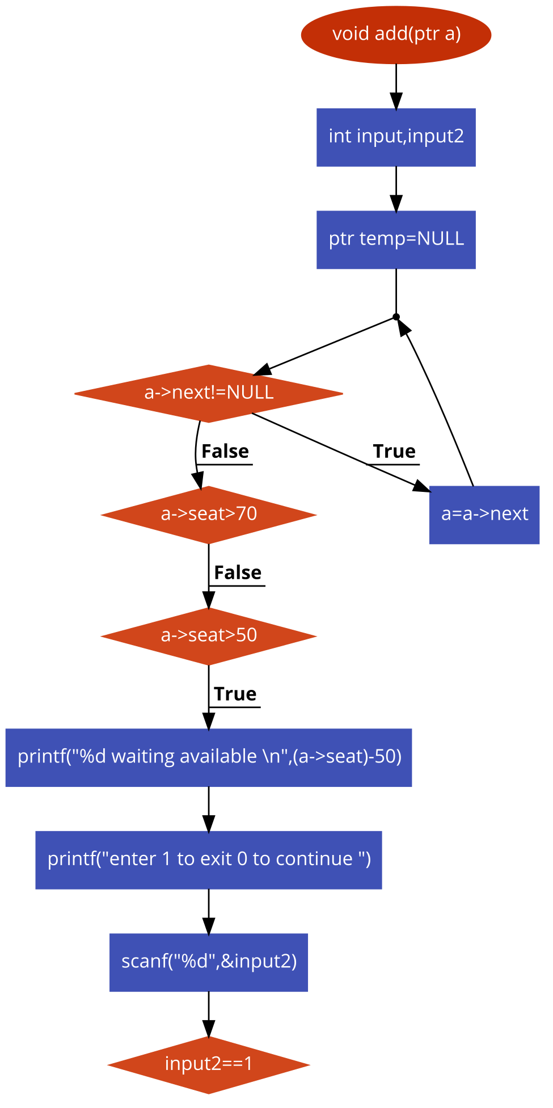

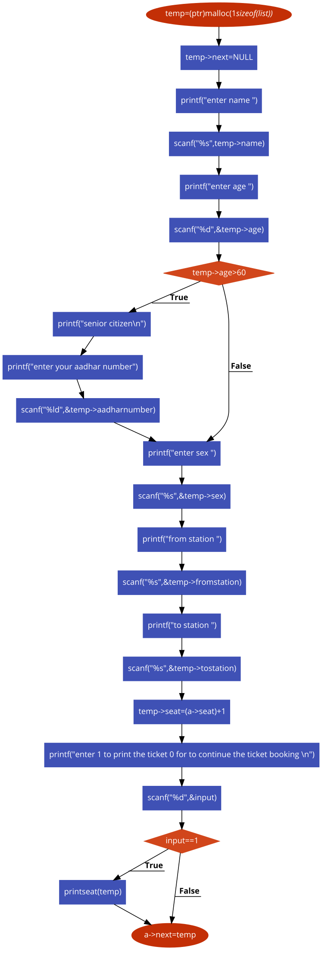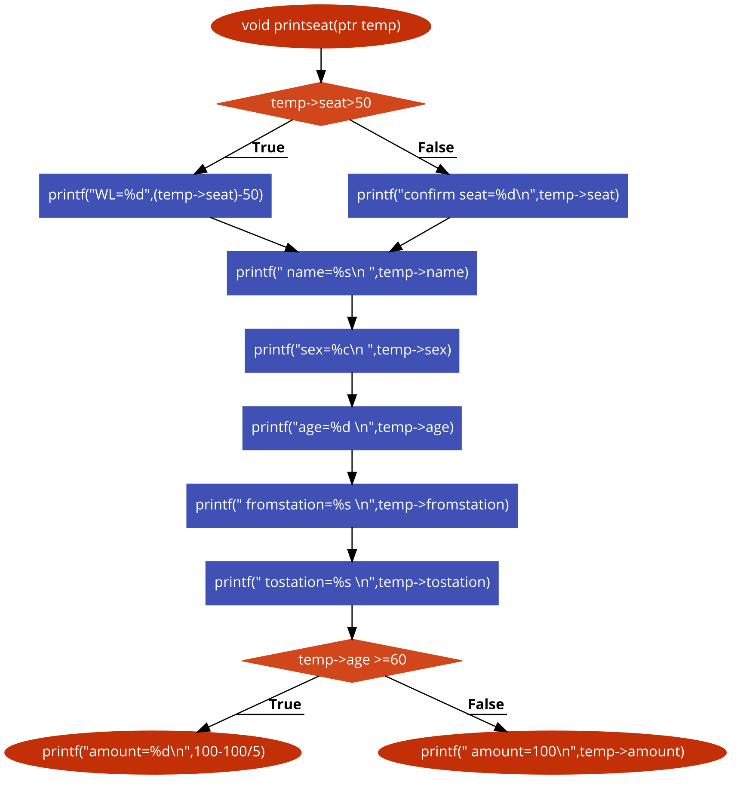

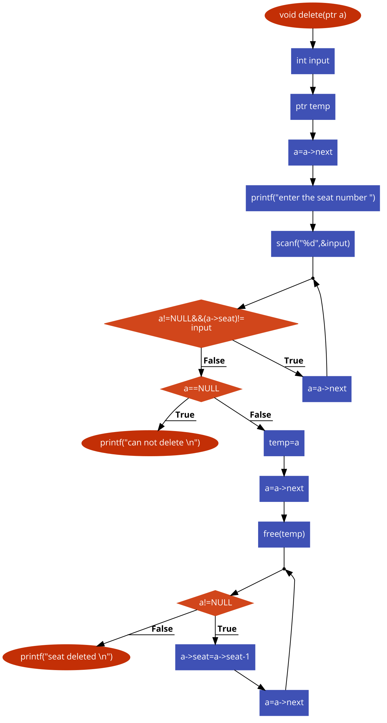

**ALGORITHM**

**Step 1:** start

**Step 2:** create nodes for memory allocation.

**Step 3:**print the option to be choosen by the passenger.

If(input==1)

Add details of passenger

If(input==2)

Delete details of passenger

If(input==3)

Print the details of all passengers

If (input==4)

Exit the booking system

**Step 4:** adding passenger details

**Step 5:** read the input

**Step 6:** if the seat number is greater than 50 print waiting available.

**Step 7:** Read the details such as name, age, sex, from station, to station of the passenger

**Step 8:** if(age>60)

**Step 9:** Read aadhar number of passenger

**Step 10:**print enter 1 to print the ticket or 0 to continue booking

**Step 11:** if(input==1)

**Step 12:**print seat number, passenger details and amount.

**Step 13:** if(seat>50)

**Step 14:**print waiting list seat number

**Step 15:** Deleting passenger reservation

**Step 16:** Read the seat number

**Step 17:** if (seat!=input)

**Step 18:**print cannot delete

**Step 19:** else print seat is deleted

**Step 20 :** Printing the chart of passengers

**Step 21:** Enter input

**Step 22:**print details of passenger

**Step 23:** Exit the booking

**Step24 :**Enter input

**Step 25:**print thank you happy journey

**Step 26:** end

**IMPLEMENTATION**

#include<stdio.h>

#include<stdlib.h>

typedef struct node

{

int seat;

char name[15];

int age;

char sex;

char fromstation[20];

char tostation[20];

long int amount;

long int aadharnumber;

struct node* next;

}list,*ptr;

void delete(ptr a);

void add(ptr a);

void printseat(ptr temp);

void print(ptr a);

void delete(ptr a);

int main()

{

int i,input;

ptr a;

a=(ptr)malloc(1*sizeof(list));

a->next=NULL;

a->seat=0;

for(i=0;i<100;i++)

{

printf("enter 1 to book a ticket \n 2 for deleting a TICKET \n 3 to print the chart \n 4 to exit the loop \n");

scanf("%d",&input);

if(input==1)

{

add(a);

}

else if(input==2)

{

delete(a);

}

else if(input==3)

{

print(a);

}

else if(input==4)

{

break;

}

else

{

printf("not able to recognise the command \n");

}

}

printf("thank you \n");

printf("happy journey");

return 0;

}

void add(ptr a)

{

int input,input2;

ptr temp=NULL;

while(a->next!=NULL)

{

a=a->next;

}

if(a->seat>70)

{

return ;

}

else if(a->seat>50)

{

printf("%d waiting available \n",(a->seat)-50);

printf("enter 1 to exit 0 to continue ");

scanf("%d",&input2);

if(input2==1)

{

return ;

}

}

temp=(ptr)malloc(1*sizeof(list));

temp->next=NULL;

printf("enter name ");

scanf("%s",temp->name);

printf("enter age ");

scanf("%d",&temp->age);

if(temp->age>60)

{

printf("senior citizen\n");

printf("enter your aadhar number");

scanf("%ld",&temp->aadharnumber);

}

printf("enter sex ");

scanf("%s",&temp->sex);

printf("from station ");

scanf("%s",&temp->fromstation);

printf("to station ");

scanf("%s",&temp->tostation);

temp->seat=(a->seat)+1;

printf("enter 1 to print the ticket 0 for to continue the ticket booking \n");

scanf("%d",&input);

if(input==1)

{

printseat(temp);

}

a->next=temp;

return ;

}

void printseat(ptr temp)

{

if(temp->seat>50)

{

printf("WL=%d",(temp->seat)-50);

}

else

{

printf("confirm seat=%d\n",temp->seat);

}

printf(" name=%s\n ",temp->name);

printf("sex=%c\n ",temp->sex);

printf("age=%d \n",temp->age);

printf(" fromstation=%s \n",temp->fromstation);

printf(" tostation=%s \n",temp->tostation);

if(temp->age >=60)

{

printf("amount=%d\n",100-100/5);

}

else

printf(" amount=100\n",temp->amount);

return ;

}

void print(ptr a)

{

a=a->next;

while(a!=NULL)

{

printf("seat number=%d\nname=%s \nsex=%c\nage=%d\nfromstation=%stostation=%s \n",a->seat,a->name,a->sex,a->age,a->tostation,a->fromstation);

a=a->next;

}

return ;

}

void delete(ptr a)

{

int input;

ptr temp;

a=a->next;

printf("enter the seat number ");

scanf("%d",&input);

while(a!=NULL&&(a->seat)!=

input)

{

a=a->next;

}

if(a==NULL)

{

printf("can not delete \n");

return ;

}

temp=a;

a=a->next;

free(temp);

while(a!=NULL)

{

a->seat=a->seat-1;

a=a->next;

}

printf("seat deleted \n");

return ;

}

**INTEGRATION AND SYSTEM TESTING**

OUTPUTS

Screen Shots:

Selecting following sub functions

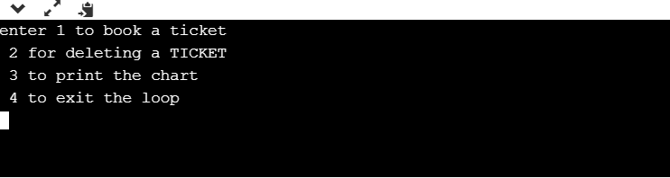

Entering passengers information

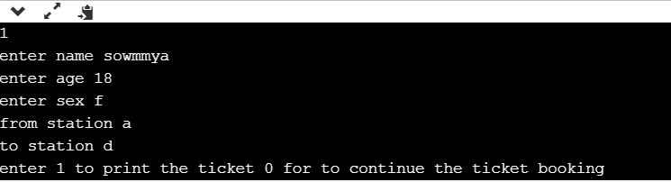

Printing the ticket

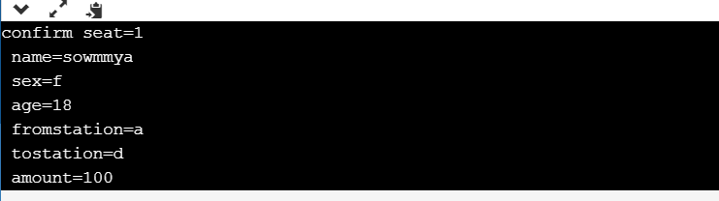

Deleting seat of passenger

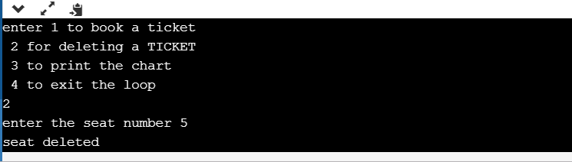

Printing the chart of passengers travelling

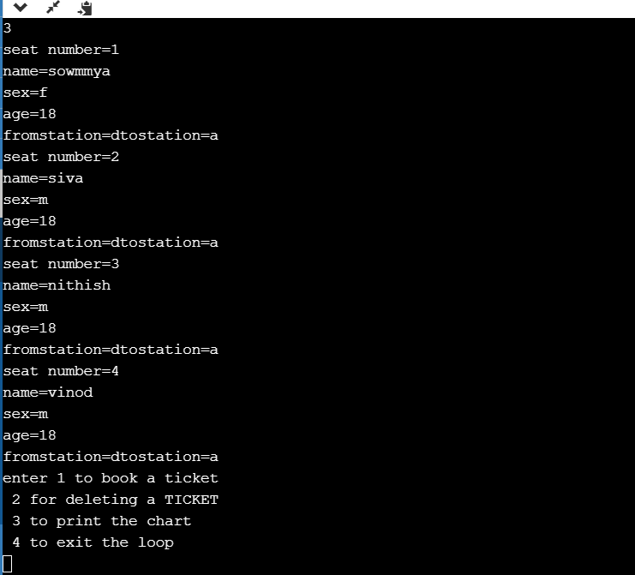

Completion of booking the ticket

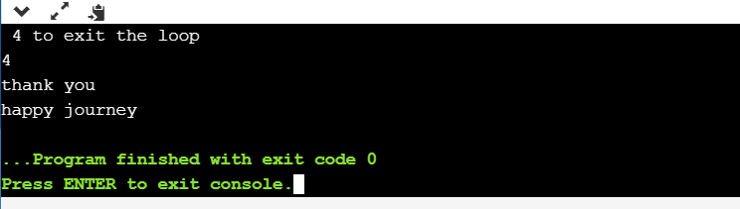

**CONCLUSION**

Here the railway booking is done online using the program developed by linked list using c and several other topics like strings etc.

By this program the passenger can book the ticket and can even get to know the status of his reservation and details of the passenger.